1. Write a short narrative about what the data means and why you chose the visualizations/colors that you did.

🡺

I have created below dashboard by using power bi visualization tool, this dashboards shows the road accident due to bad weather conditions:

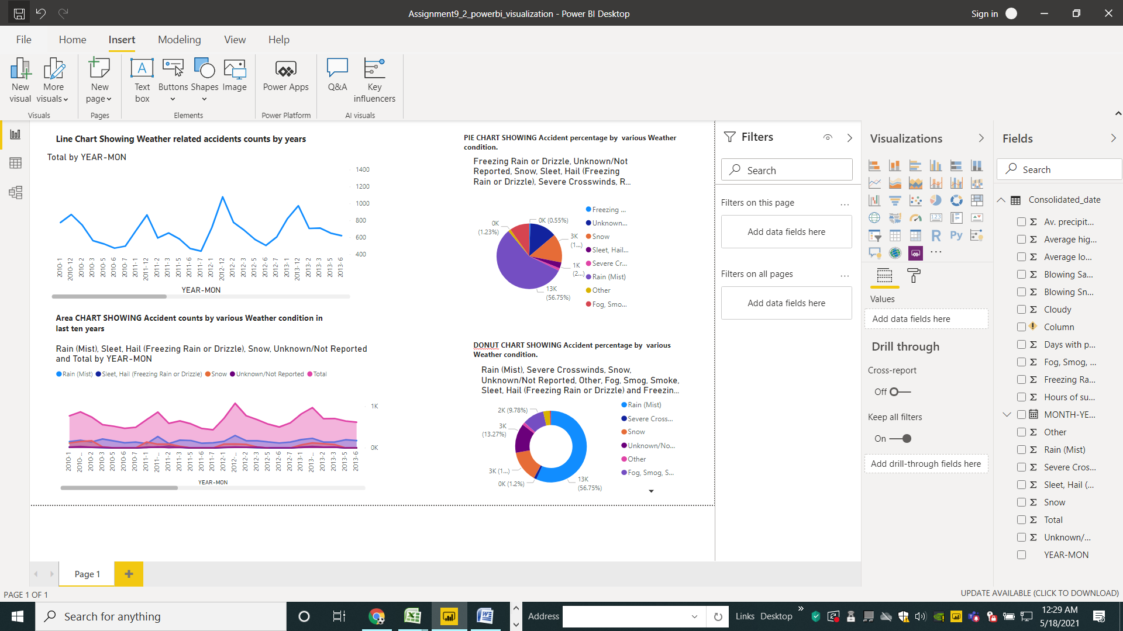

Used Visualizations:

1. Donut Chart -- it is showing the relation ship of different types of bad weather conditions which are contributing in weather related accidents
2. Pie Chart – the relation ship of different types of bad weather conditions accidents parts with whole
3. Area Chart : here area chart is showing accidents counts due to multiple bad weather conditions across last ten years (filled with different colors)
4. Line chart – it showing the over all accidents counts over the time frame of 10 years